CIS40A Lab 3-1: NIC Configuration and MAC Address in Windows 10

In this exercise, we will use Windows 10 Virtual Machine, NIC and wireless adapter and Power Shell. The Windows 10 virtual machines on external hard drive in PSC-16. We will explore a Network Interface Card setting. Refer to below procedures and questions.

Part A: Booting Windows 10 VM
- Login to the classroom computer and attach the external hard drive.
- Browse to This PC à USB (external hard drive, E:) and copy-paste CIS40AWindows10VM folder onto the computer desktop.
- On the computer, use the Windows search bar to search for “virtualbox”, then click on VirtualBox app.
- In VirtualBox app, click Machine, then click Add+
- Browse to This PC à Desktop à CIS40AWindows10VM folder and its subfolder à CIS40AWindows10VM.vbox (blue icon),
- On VirtualBox app, click Start (green arrow).
- Login to Windows VM:
Username: CIS40AStudent
Password: CIS40A!

Part B: NIC Driver and Transceiver
- On Windows 10 VM, right-click Windows Start button and select Computer Management console.
- Click Device Manager on the left side of the console.
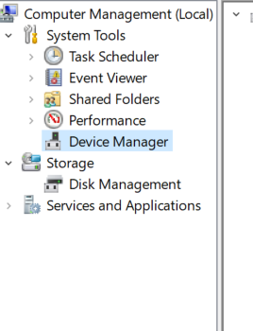
- In the center of the console, click Network Adapters to see the detailed list.
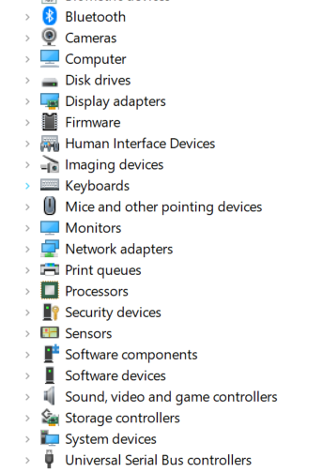

- Right-click the network adapter (not Wi-Fi or virtual adapter) and select Properties.
- Click Events tab and answer the below questions.
- When was the device installed? 9/18/2023 @ 2:39:27 PM
- When was the device configured? 9/18/2023 @ 2:39:27 PM
- Click Driver tab and answer the below questions.
- What is the version of driver installed for the NIC? 8.4.13.0
- What date was the drive installed? 03/23/10
- Click Advanced tab, you should see a list of properties that may include transceiver, transfer speed, and duplex properties. You may also see settings such as Wake On LAN and Jumbo Frame. The settings that appear on the Advanced tab will depend on your driver.
Take a screen capture for lab assignment submission.
- Close the Properties window and Computer Management Console.

Part C: Network Adapter Settings and Addresses
- On Windows 10 VM, type “settings” into Windows search bar to locate and open Settings applet.
- Click Network & Internet. Then, click on Ethernet.
- Double-click Ethernet adapter and click Properties, Details button.
- Open browser to use OUI lookup tool, https://maclookup.app/ to identify the organization that manufactured the network adapter.
- Can you locate the organization that produced the adapter? If so, who manufactured the network adapter? PCS Systemtechnik GmbH
*If you are unable to locate the above information, Try using other OUI lookup tool such as Wireshark OUI lookup tool or Mac Finder Tool.
- Return to Hardware Properties page and answer the below questions. – DO NOT COMPLETE RED PART
- What is the Link Speed of the wireless adapter?
- What protocol is used?
- What security type is used?
- What is the network band and channel?
- Close the Wi-Fi window. – DO NOT COMPLETE
- In Windows Search bar, type “power shell” to open Windows Power Shell.
- In Powershell, input the following command and press Enter: Get-NetAdapter
- Take a screen capture for lab assignment submission.
- Which adapter has the highest throughput/speed? Ethernet Adapter, 1 Gbps
- Return to Power Shell and enter command: ipconfig /all | findstr "Description Physical"
- What is the Description of the Ethernet adapter or Wireless Adapter? *Do not use the VirtualBox or VMWare adapter! Intel (R) PRO/1000 MT Desktop Adapter
- Return to Power Shell and enter command: wmic nic where PhysicalAdapter=True get MACAddress,Name
- Take a screen capture for lab assignment submission and answer the below question.
- How is the output different from step 8 and 9? Step 9 lets you pick and choose the info you need.
- Which step do you find most useful to acquire the system MAC address? I prefer Get-NetAdapter, but I see where wmic is useful as well
- Close Power Shell.
- In Windows VM Search Bar, type “control panel” to locate and open Control Panel.
- Click Network and Internet
- Click View Network Status and Tasks
- Click the network adapter listed next to Connections on the right side of the window.
- Click Details button.
- Take a screen capture of the Network Connections Details page for lab submission.
- Click Close button to close the Network Connections Details page.
- Close other windows.
Login Canvas to submit a document that contains screen captures, questions, and answers of this lab.

